Assignment 1

step1:open url in any web browser like (chrome,firefox,explore,etc.)

step2:right click on page click on inspect and find encoded data hide in web page see in picture.

**Highlight part is encoded value**.

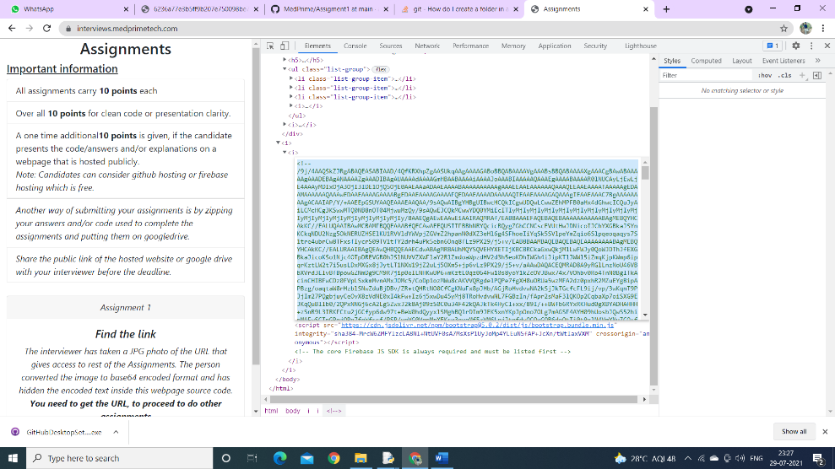

Step3: how to decode and find another url for further assignment using code see code my uploaded and check output images.